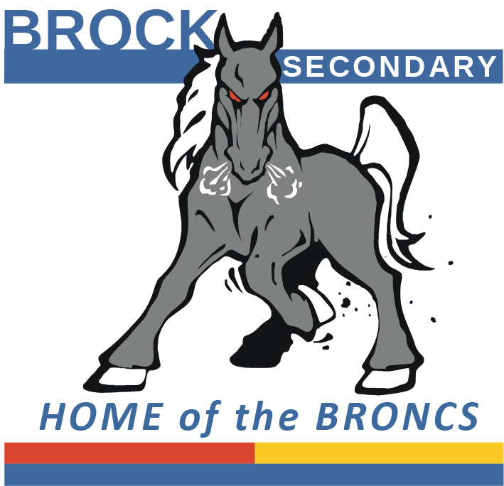
BROCKLEHURST SECONDARY SCHOOL
985 Windbreak Street
Kamloops, B.C. V2B 5P5
Telephone (250) 376-1232 Fax (250) 377-2263
Web Address: http://brocksec.sd73.bc.ca

Meals Program PERMISSION FORM
Oct 1-30, 2026 MENU

Student Name ______________________________________________Grade__________________________

Parent / Guardian Signature__________________________________ Amount Enclosed________________ Cash or cheques only.
SIGN and RETURN no later than Sept 23, 2026 to ensure your order. All meals come with Veggie or Fruit.

DAY | DATE | LUNCH – Please circle choice | CHECK Options | Price
Thurs | 1 | Beef Burrito or Bean and Cheese Burrito |  | $7.00
Fri | 2 | Cheese, Crackers, Sausage or Just Cheese and Crackers |  | $7.00
Mon | 5 | Pizza Bagel |  | $7.00
Tue | 6 | Pancakes and Bacon or Pancakes with Fruit Cup |  | $5.50
Wed | 7 | Penne Alfredo with or without Garlic toast |  | $6.25
Thurs | 8 | Grilled Cheese and Ham or Grilled Cheese |  | $7.00
Fri | 9 | Cheeseburger or Veggie Burger |  | $7.00
Mon | 12 | No School | N/A
Tue | 13 | Cheese Perogies |  | $7.00
Wed | 14 | Spaghetti With or Without Meat Marinara Sauce |  | $7.00
Thurs | 15 | Three Cheese Pizza |  | $7.00
Fri | 16 | Chicken Burger or Veggie Burger |  | $7.00
Mon | 19 | Chicken Nuggets or Veggie Nuggets |  | $8.00
Tue | 20 | BBQ Beef Bun or Veggie Bun |  | $6.50
Wed | 21 | Mac and Cheese |  | $7.00
Thurs | 22 | Beef Burrito or Bean and Cheese Burrito |  | $7.00
Fri | 23 | No School | N/A
Mon | 26 | Pizza Bagel
Tue | 27 | Pancakes and Bacon or Pancakes with Fruit Cup |  | $5.50
Wed | 28 | Penne Alfredo With or Without Garlic Toast |  | $6.25
Thurs | 29 | Grilled Ham and Cheese or Grilled Cheese |  | $7.00
Fri | 30 | Hot Dog or Veggie Dog |  | $5.50

Total: _________

