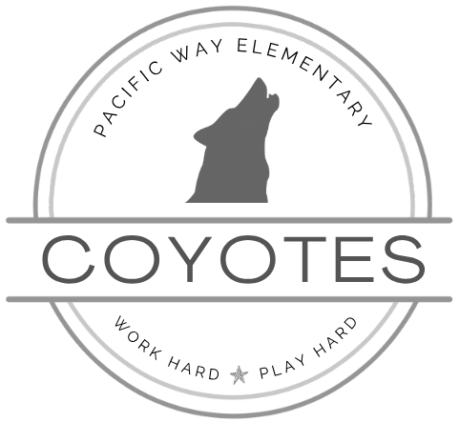
PACIFIC WAY ELEMENTARY
2330 Pacific Way
Kamloops, BC V1S 1S8
Phone: (250) 851-0632 Fax: (250) 377-2255 pacific-way-office@sd73.bc.ca
Principal: Katrina Sewell (ksewell@sd73.bc.ca) Vice-Principal: I-Wen Bluhm (ibluhm@sd73.bc.ca)

February 2026
Principal’s Note:  We have enjoyed warmer than usual weather over the past month. Outside break time has been spent playing with friends on the playgrounds, soccer on the fields, 4 square or basketball on the tarmac, and building in the sand box. We have even seen sidewalk chalk art in action. Not a typical January, to say the least.  With the warmer weather, however, comes mud and wet grass. Please ensure your child comes to school prepared for being outside in all kinds of weather at recess and lunch time. Also consider sending your child with a change of clothes to change into after they come in from a messy outdoor playtime.  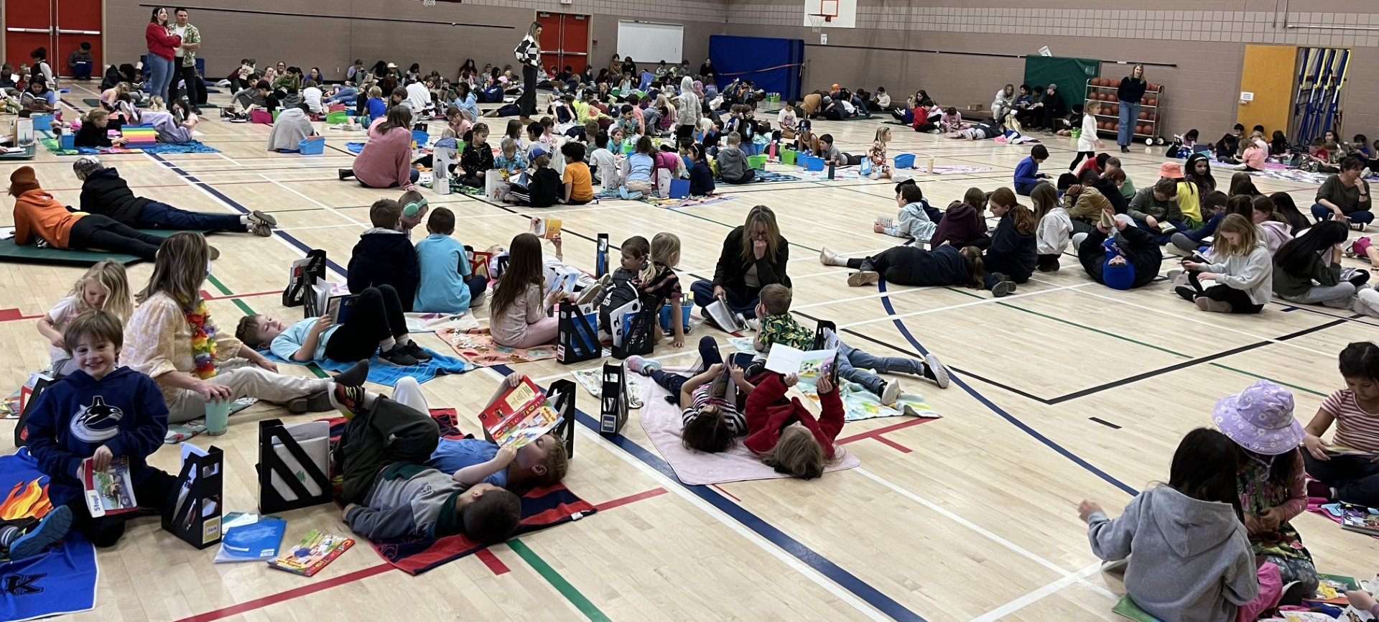  Unplug and Play week was a HUGE success, thanks to Mrs. Piva and Mrs. Bond, who organized a week full of fun events, including Wednesday’s Book and Beach day!  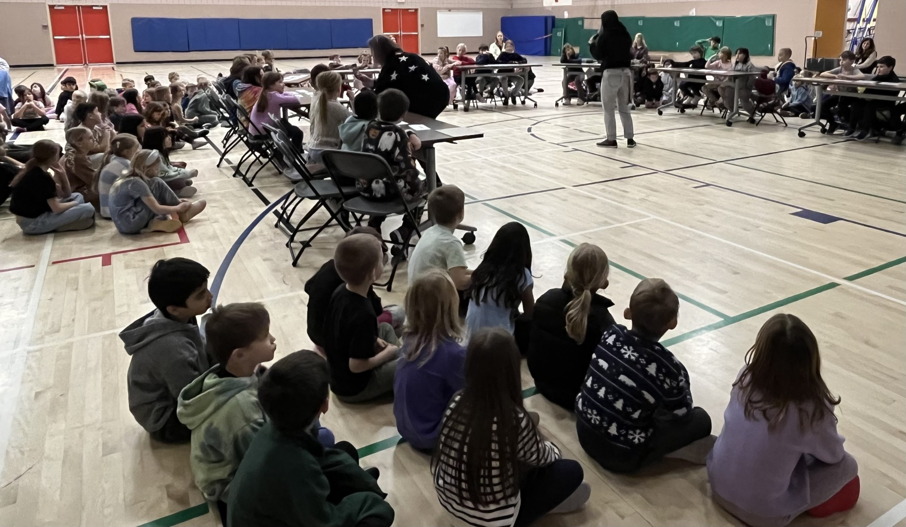  We ended the week with Let’s Learn Secwepemctsin with Mrs. Bluhm and Mr. Michel. Students participated in a Battle of the Books style challenge after learning 5 new winter-related Secwepemctsin words.  This month we celebrate Random Acts of Kindness. Staff and students will be promoting and practicing kindness towards others, and students have the opportunity to receive Kindness Gotchas with the incentive of earning an extra afternoon recess at the end of February. Our school goal is to earn 800 Gotchas throughout the month, or 2 per student. Later in February students will learn about the Seven Grandfather Teaching, Love, with a focus on finding peace with yourself and loving yourself.  Mrs. Marlatt and Mrs. Pagnotta arranged a visit from a few of the Kamloops Blazers on February 24th. There will be a school-wide floor hockey game, where students from each class will have an opportunity to play with the Blazers. In addition, one student from each class will be drawn to win 2 tickets (one for them and one for their accompanying adult) to attend the February 28th Blazers game.  Each year we do a number of safety drills at school. This includes 5 fire drills and 2 lockdown drills yearly. Later in February we will do the first of 2 lockdown drills. Staff will be preparing for the drill and reviewing safety routines with our students.  Sincerely,  Mrs. Katrina Sewell  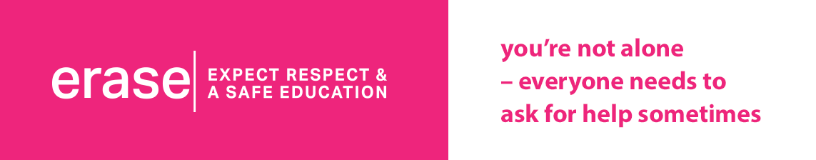  https://www2.gov.bc.ca/gov/content/erase/help | Dates To Remember
  Random Acts of Kindness:
  Grade 6 students in Mrs. Littlejohn’s class will read a daily school-wide challenge on the announcements each morning this month. Feel free to take part with us at home.
  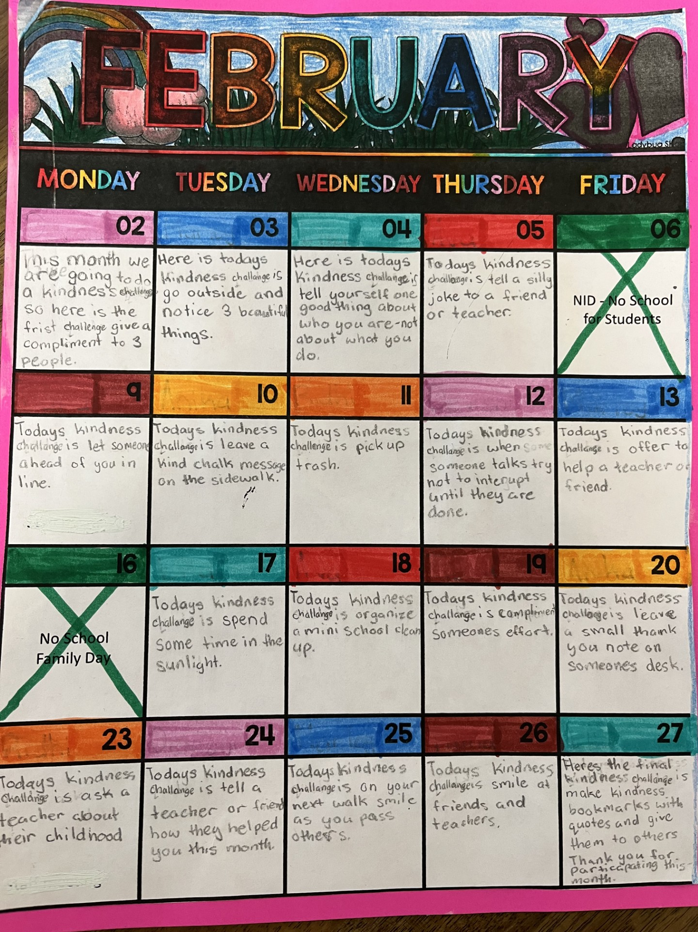
  
  PINK SHIRT DAY
  Wednesday,
  February 25th
  ROUNDABOUT / PARKING
  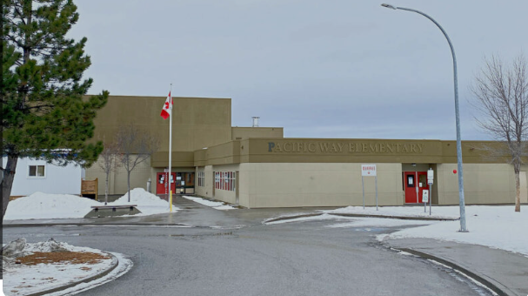
  Thank you to those of you who have been doing your part to keep the traffic in the roundabout moving by staying with your vehicle while you drop off or pick up your children.
  If you need to leave your vehicle to meet or assist your child, please remember to park in the upper parking lot or along the street, being mindful of neighbours’ private driveways and keeping crosswalks clear to ensure the greatest student visibility.
  Parent tip: There is parking across the street from the lower field at the soccer fields.
  Noon Hour Supervisors Needed
  With winter upon us, we are currently needing noon hour supervisors for all 5 days of the week. You will receive an honorarium of $12 for the hour.
  Please contact Mrs. Sewell by phoning the school or emailing at ksewell@sd73.bc.ca. We will give your contact information to Cathy, our supervisor organizer, and she will reach out to add you to the schedule.
  
  Friday, February 6
  Parents Advisory Council (PAC) Corner:
  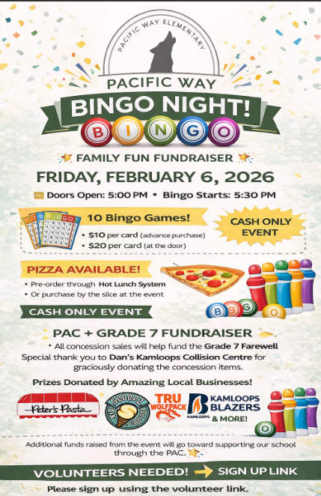
  Hot Lunch Orders — Winter Session:
  - 🍴 Winter session is now in effect. Special note: paying by cash, cheque, or e-transfer helps the PAC save on credit card fees, raising more funds for the school. 🔗 Order here: https://pacificway.hotlunches.net/
  Mabel’s Labels Fundraiser:
  - 🏷️ With every purchase, the school receives 20% back!
  - Visit mabelslabels.ca and at checkout you'll see a "Support a Fundraiser" box, type Pacific Way Elementary, select our school and complete your order!
  Next PAC Meeting:
  - Thursday, February 19 @ 3:00 PM in the Library — everyone is welcome!
  Kindergarten Registration:
  We look forward to welcoming our new Kindergarten students for the 2026-2027 school year. It is important that we get our students as soon as possible as it helps with staffing and school organization.
  Pacific Way Elementary Registration begins the week of February 2-6. The registration process is as follows:
    - Pick up a registration package from the school (or complete this digital copy) and return completed forms to school
    - Parents will be required to provide child's care card, proof of address, child's birth certificate, and other applicable documents
    - Registration is based on the catchment boundaries, as set for the 2026 school year
  If you have questions or if you would like help completing your registration, please contact the school.
  To learn more about Kindergarten in SD73:
  - Explore: Welcome to Kindergarten Handbook
  Pacific Way’s Chromebook Lending Library
  
  THANK YOU to our generous PAC for contributing $3000 to our Chromebook replacement project. Many of our Chromebooks are aging (some are 8+ years old), and we have committed to replacing Chromebooks so that they are of optimal use for students. Earlier this year we purchased 22 new Chromebooks, and with the additional $3000 we will be able to purchase 9-10 more.
  As we replace our aging Chromebook, the district will do a clean up and reset of them so that we are able to breathe a bit more life into them. While they aren’t able to keep up with the high volume of a classroom, they will be fine for a student who needs to finish up a project at home. If you have a child who needs to use a Chromebook, you can sign one out from the school just like a library book.
  How to Borrow One:
  - Let your child’s teacher know you’d like to sign out a Chromebook.
  - When your child goes to the library for their book exchange, the librarian will check a Chromebook out to your child, in addition to their library book.
  - You may keep it for 2 weeks.
  - Need more time? Email the teacher for an extension.
  - Return it by the due date.
  February 2-6 | Kindergarten Registration
  February 6 | Non-Instructional Day - No school
  February 6 | PAC Evening Bingo Event
  February 16 | Family Day - No School
  February 19 | PAC Meeting at 3:00pm
  February 24 | Kamloops Blazers Visit / Jersey Day
  February 25 | Pink Shirt Day
  March 11 | Term 2 Learning Updates posted
  March 14 - 29 | Spring Break

